Dalber's Hood Test
Sanded only
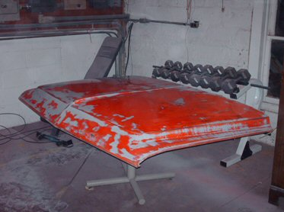
After One Coat
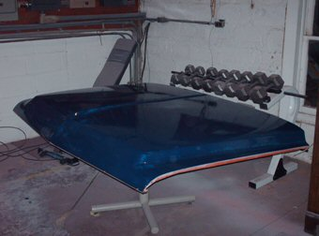
View of original paint after one coat (very thin coats each time)

